November 2020

Date | Activity | Timings | Location | Dress | OOD | QM | POOD | Canteen PO
03 Nov | Parade Night | 1845-2000 | Google Meet | Civilian w/Patriot T-Shirt
03 Nov | Communicator’s | 2000-2200 | Google Meet | Civilian
04 Nov | Fitness / Biathlon | 1900-2000 | Zoom | Civilian
04 Nov | UPAR | 2015-2100 | Google Meet | Civilian
10 Nov | Parade Night – Special Guest Lt(n) Harper | 1845-2000 | Google Meet | C1
10 Nov | Communicator’s | 2000-2200 | Google Meet | Civilian
11 Nov | Remembrance Day | TBD | TBD
11 Nov | Fitness / Biathlon | 1900-2000 | Zoom | Civilian
11 Nov | UPAR | 2015-2100 | Google Meet | Civilian
17 Nov | Parade Night | 1845-2000 | Google Meet | Civilian w/Patriot T-Shirt
17 Nov | Communicator’s | 2000-2200 | Google Meet | Civilian
18 Nov | Fitness / Biathlon | 1900-2000 | Zoom | Civilian
18 Nov | UPAR | 2015-2100 | Google Meet | Civilian
24 Nov | Scavenger Hunt | 1900-2000 | Google Meet | Civilian
25 Nov | Fitness / Biathlon | 1900-2000 | Zoom | Civilian
25 Nov | UPAR | 2015-2100 | Google Meet | Civilian

Upcoming Activities
10 Nov 2020 – Special Guest, Lt(n) Harper will be joining us on November 10, 2020. You are requested to wear your C1 uniform. See Below for a detailed description of the C1 Uniform. Remember to wear your poppy!
24 Nov 2020 – Scavenger Hunt, break out into houses, find items, and complete challenges.

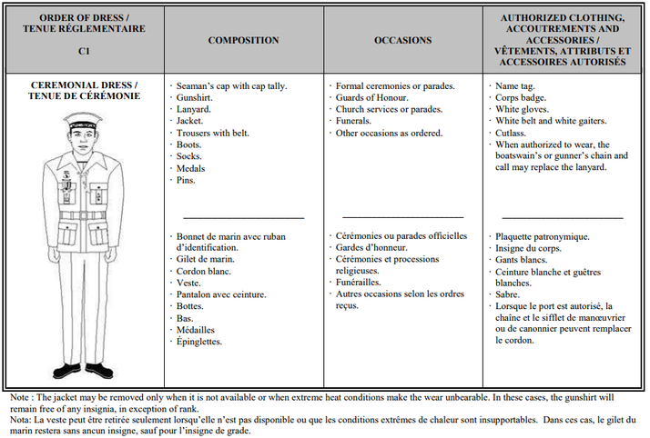

Cadet Dress
C-1 → Ceremonial Dress → Cap, Gunshirt, Tunic, Medals
C-2 → Mess Dress → Cap, White dress shirt, bowtie (male), cross-over tie (female), Medals
C-3 → Service Dress → Cap, Gunshirt, tunic, ribbons
C-3A → Service Dress → Cap, Gunshirt (no tunic or ribbons)
C-4 → Training Dress →Blue shirt, pants, boots and ball cap
SP-1 → Patriot Shirt / Camp Shirt / Issued Black Shirt, shorts, running shoes, Patriot Cap (or Black issued cap), Water bottle

