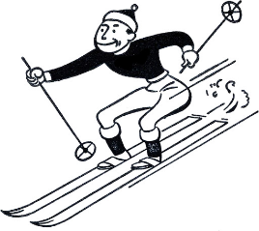
RCSCC PATRIOT SKI TRIP

Where: Snow Valley Ski Resort, 2632 Vespra Valley Rd, Minesing, ON L0L 1Y3 (No transportation provided)
When: February 15th 2020, 1030-1530
All participants MUST complete and bring in the waiver form before/by the date to participate. We are meeting AT the resort, not the Optimist Hall; you must find your own transportation. You may bring your own skis/board+gear if you have any.
Prices:
Lift tickets - Lift Tickets are $45 if you are under the age of 16, $55 if you are over. We will pay partially depending on your tagging shifts.
Snow Tubing - $43 for 10 rides or $63 for 15 rides. We will pay partially depending on your tagging shifts
Rentals - U16: $30, 16+: $33, additional $10 for helmet/boots
Reimbursements
6 Shifts | $50
5 Shifts | $40
4 Shifts | $30
3 Shifts | $20
2 Shifts | $15
1 Shift | $10
0 Shifts | $0

Kit List:
- Health Card
- Water Bottle
- Any Ski related gear
- Appropriate outerwear
If you or a parent have any questions, feel free to email me at aaron.cho17@hotmail.com or ask your DPO

