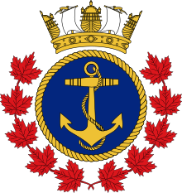
Royal Canadian Sea Cadet Corp Patriot 221
55 Forhan Drive, Newmarket, ON
Telephone: (905) 895-3038

_____________________has permission to attend the rock climbing activity on Thursday, April 18th, 2019.
Note: Please also sign and return the of Rock and Chalk permission form attached

Where:
Of Rock and Chalk - 482 Ontario Street, Newmarket, ON L3Y2K7, CA

When:
Thursday, April 18th. 2019
Drop off time: 6 : 45 pm
Pick up time: 9 :00 pm
Cost:
0-3 Tagging Shifts: $25
4-6 Tagging Shifts: $15

Please wear active clothing and running shoes suitable for physical activity, and bring your health card. Also, please leave all valuables at home as the corps is not responsible for lost/broken valuables and they are not necessary for the activity.

