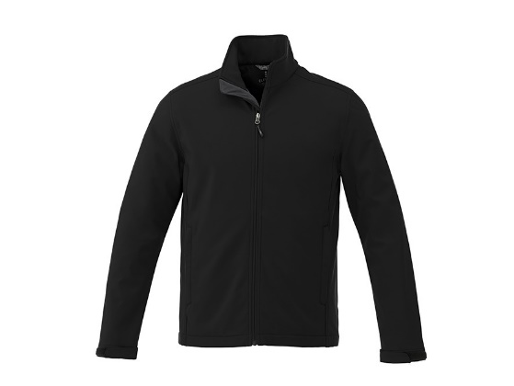
JACKET (BLACK) $55 (cadets) $75 (other)
Patriot Crest on left chest embroidered in colour
PATRIOT on back screen print (Additional $5 per jacket for BIATHLON)
Name embroidered on right sleeve
OUTERSHELL: 100% Polyester mechanical stretch woven bonded to 100% Polyester anti-pill microfleece with waterproof (8000mm), breathable membrane (400 g/m2) and water repellent finish, 270 g/m² (8 oz/yd²).
LINING: 100% Polyester brushed tricot knit upper storm flap and pocket bags.
WARMTH RATING: Warmth Level 1 - Cool/Spring-Fall Night/Mild Winter Day (10°C to -5°C/ 50°F to 23°F

NAME ON SLEEVE: ________________ SIZE (S-5XL): ____________ NAME ON BACK: ________________
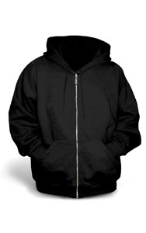
SWEATER (BLACK) $30 (cadets) $45 (other)
Full Zip Fleece Sweaters
Patriot Crest on left chest embroidered in colour
PATRIOT on back screen print
Name embroidered on sleeve

NAME ON SLEEVE: ________________ SIZE (S-2XL): _________________

GOLF SHIRT (BLACK) $15 (cadets) $25 (other)
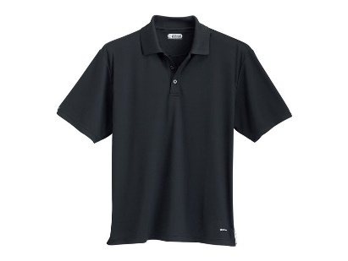
Patriot Crest silk screened on left chest

Advanced WEBTech™ 100 wicking fabric offers breathable moisture management. Classic flat knit collar with long, slimming two-button placket (women's). Contrast 'X' shaped bartacks at slits and taping on inside of slits.
FABRIC: 100% Micro Polyester Double Pique with In-House Wicking. 145 g/m2 (7 oz/linear yd).
SIZE (S-2XL): _________________

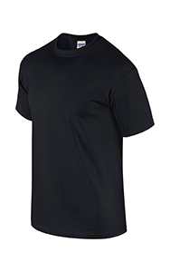
T-SHIRT (BLACK) $5
Patriot Crest silk screened on left chest

SIZE (S-2XL): _________________

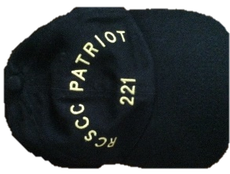
PATRIOT BALL CAP (CAN BE WORN IN WORKDRESS) $5

QUANTITY ___________

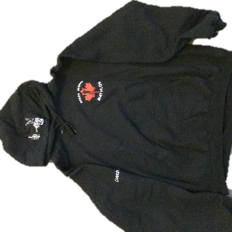
BIATHLON SWEATER (BLACK) $35 (cadets) $45 (other)
Full Zip Fleece Sweaters / Pullover Fleece
Biathlon Crest on left chest embroidered in colour
Biathlete crest and target embroidered on hood
BIATHLON on back screen print
Name embroidered on sleeve

NAME ON SLEEVE: ________________ SIZE (S-2XL): _________________

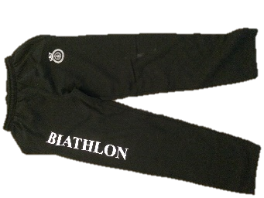
BIATHLON SWEATPANTS (BLACK) $35 (cadets) $45 (other)
Option 1: Fleece pants with open bottom (no cuff).
Option 2: Wind Pant no liner (not water proof)

Patriot Crest on the right
PATRIOT / MARKSMANSHIP / BIATHLON / DRILL TEAM down left leg.

Please circle one: PATRIOT / MARKSMANSHIP / BIATHLON / DRILL TEAM
FLEECE PANTS / WARM UP PANTS SIZE (S-XL): _________________

